Sohaib Sarosh Shamsi | 21K-3278-D – LAB 09 OS

Question 1 part a

Question 1 part b

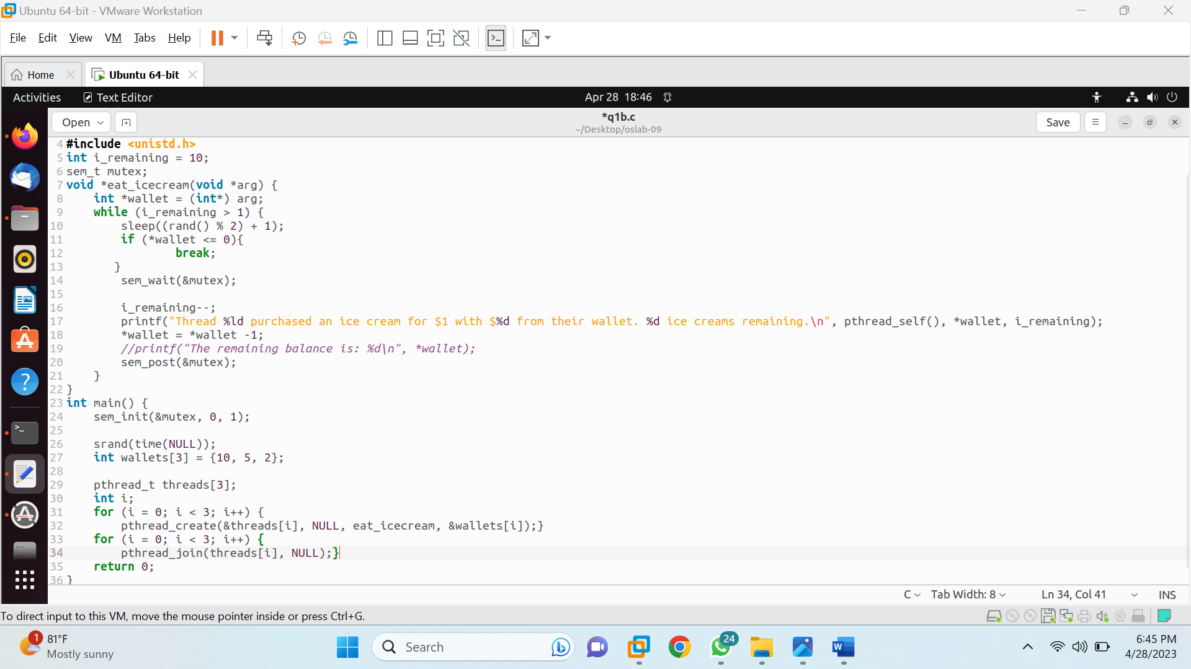

Question 2

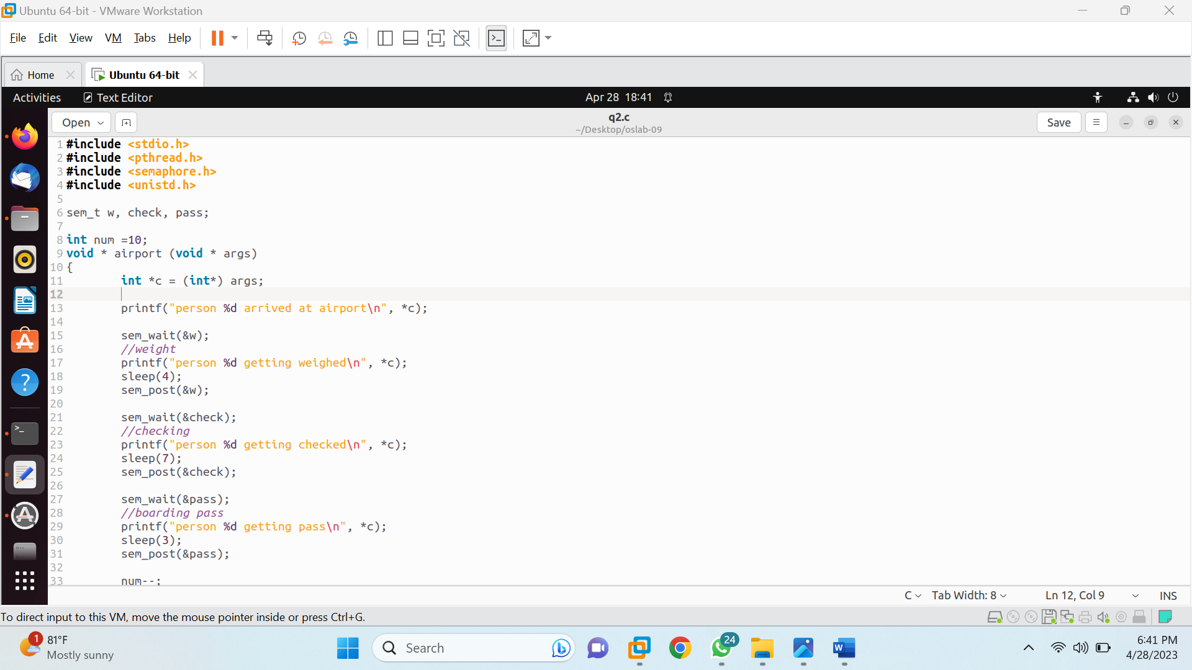

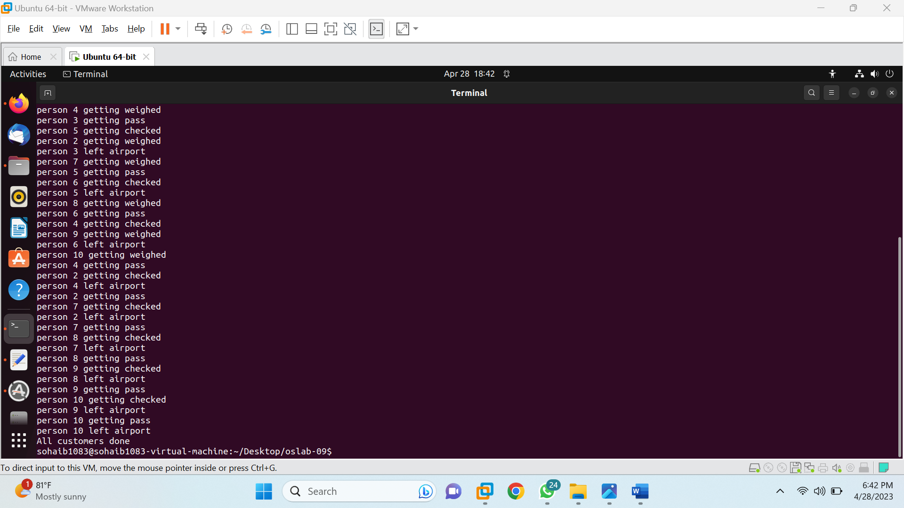

Question 3



